**FORMAN CHRISTIAN COLLEGE (A CHARTERED UNIVERSITY)**

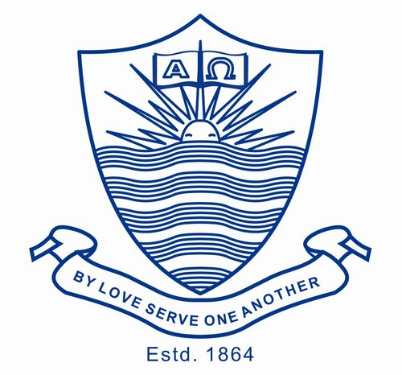

**Technology Management**

**SECTION A**

**Sheraz Khalid**

**21-10944**

**Assignment#1**

# **Technology Management:**

Information technology management is the process whereby all resources related to information technology are managed according to an organization's priorities and needs. This includes tangible resources like networking hardware, computers and people, as well as intangible resources like software and data. The central aim of IT management is to generate value through the use of technology. To achieve this, business strategies and technology must be aligned.

# **IT Operations Management:**

IT Operations refers to the set of processes and services that are administrated by an I.T department within a larger organization of business. It operations one of the four defined functions in the ITIL best practices framework for it service management along with application management , technical management and the service desk as a discreetly identified function of the idea organization ITOPS often function as a distinct working group within the it department so an IT operations team really consists of a group of IT operators that is led by an it operations manager so in short it just refers to a set of processes and services that are administrated by an IT team.

IT Operations Management do these operations. Run Solutions, Manage Infrastructure, Manage Configurations, Evolve Infrastructure, Mitigate Disasters, Govern IT Operations.

# **IT Service Management (ITSM):**

IT Service Management (ITSM) is the process of managing, delivering, designing and improving the IT services an organization provide to its end users. The main aim behind IT Service Management is to deliver of IT as service.

# **IT asset management (ITAM):**

IT Asset Management is the process of making the inventory, tracking, maintaining and disposing of organizational technology assets. The aspect of ITAM is to find out how IT supports business especially for end-user. ITAM is mostly a subset of the IT service management process.

# **Relationship:**

Technology management covers the top of all IT business hierarchy. All IT managers, employees or even it teams comes under the umbrella of its supervisor. The technical manager sends, supervises, advises and sets the desired goals from the IT department. The IT operations management team ensures that tasks by the technology manager assigned to developers have a technical environment that is equipped with the required configuration and infrastructure along with technical security measures. The IT service management team plays the role of technical support and repairs damaged technology products and replaces them. They also provide services outside the IT department and assist non-technical departments with technical issues. IT Asset Management helps maintain the inventory of all the company's technical products and advises the technology manager on asset management and sales and their replacement with minimal financial loss to the business

**Role of IT Manager in Service Management and Operations Management:**

The IT Manager in the Service Management responsible for organization working according to the framework which they are provided and it is responsible for product repair, upgrade and other technology which are used in organization are met the requirement of framework. The IT Manager in Operation Management is responsible to make sure the proper working IT infrastructure. They ensure that the operation of infrastructure accordance with specifications, cost and timeline.